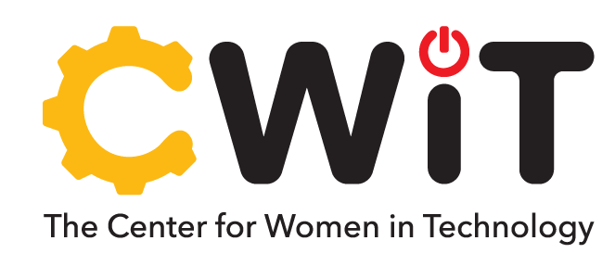
For individuals and organizations that wish to support our diverse pipeline of talented students in computing and engineering majors.


INDUSTRY ENGAGEMENT OPPORTUNITIES
Category* | Description | Opportunities | Contact
Individual Donor | Individual who makes a financial gift (one time or recurring) to support students and/or programs. | - Individual scholarships  - Travel awards to conferences  - Fund specific initiatives (aligned with donor’s interest/priority) | Meredith Watson  Development Officer  Office of Institutional Advancement mwatson4@umbc.edu https://giving.umbc.edu/
Corporate Partner | Corporate organization that makes a financial gift (one time or recurring) to support students and/or programs. | - Individual or cohort scholarships  - Travel awards to conferences  - Fund signature programs and customized events | Dakia Kelly-Adams  Associate Director of Corporate Partnerships Office of Institutional Advancement dkadams@umbc.edu
Professional Volunteer | Individual with professional experience in a computing, information or engineering field. | - Mentor a Scholar  - Participate in networking events  - Speak at an event as keynote or on a panel | Jess Myers  Associate Director  Center for Women in Technology jessm@umbc.edu https://cwit.umbc.edu/industry/
Recruitment | Employers (including Human Resources professionals) who wish to participate in UMBC career fairs and other scheduled activities to reach students for recruitment purposes. |  | Paige Bauder  Associate Director  Employer Relations & Recruitment Programs Career Center  paige2@umbc.edu
*Industry partners can engage with CWIT in any combination of the above categories. For example, an employee of a corporate partner may attend a CWIT event as an industry professional volunteer and also make an individual gift as an individual donor to support a particular student or initiative.

Updated 3/6/2025

